**Discrete Mathematical Structures**

**Week-11**

**Long Descriptive Questions**

**1. Write short note on rooted tree give example**

A rooted tree is a tree data structure where one vertex is designated as the root, and all other vertices are directed away from the root. This means that each vertex in the tree has a unique parent, except for the root, which has no parent. The edges in the tree are directed, and they represent the parent-child relationships between the vertices.

Here's an example of a rooted tree:

A

B C

D E F G

In this tree, vertex A is the root, and the edges point away from it. Vertices B and C are its children. Vertex B has three children: D, E, and F. Vertex C has one child: G.

This tree represents a hierarchy where A is the highest level, and B and C are the second level. The third level consists of vertices D, E, F, and G. The parent-child relationships in the tree help to organize the hierarchy and make it easy to navigate.

**2. Draw all the distinct binary trees having seven vertices and height**

Binary trees if every internal vertex of a rooted tree has at most 2 children the tree is called binary tree.

* **Complete binary tree** if every internal vertex of rooted tree has exactly two children the tree is called full binary tree.

A complete binary tree is just like a full binary tree, but with two major differences

* All the leaf elements must lean towards the left.
* The last leaf element might not have a right sibling i.e. a complete binary tree doesn't have to be a full binary tree

Note:

* A full binary tree sometimes referred to as a proper or plane binary tree is a tree in which every node has either 0 or 2 children
* Another way of defining a full binary tree is a recursive definition.
* A full binary tree is either a single vertex or a tree whose root node has two subtrees, both of which are full binary trees

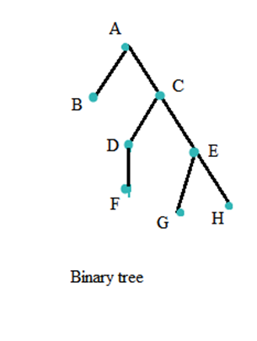Examples of binary tree and full binary tree

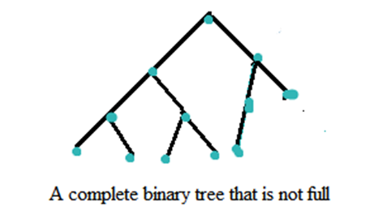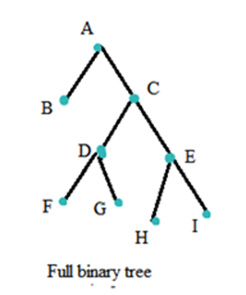

Binary tree full binary tree a complete binary tree that is not full

* In a complete binary tree every level, except possibly the last, is completely filled, and all nodes in the last level are as far left as possible.
* It can have between 1 and 2h nodes at the last level h.
* A complete binary is a perfect tree whose rightmost leaves (perhaps all) have been removed. Some authors use the term complete to refer instead to a perfect binary tree as defined below, in which case they call this type of tree (with a possibly not filled last level) an almost complete binary tree or nearly complete binary tree.
* A complete binary tree can be efficiently represented using an array.
* **Perfect binary tree** a perfect binary tree is a binary tree in which all interior nodes have two children and all leaves have the same depth or same level.

Example of a perfect binary tree an example of a perfect binary tree is the ancestral chart of a person to a given depth, as each person has exactly two biological parents (one mother and one father.

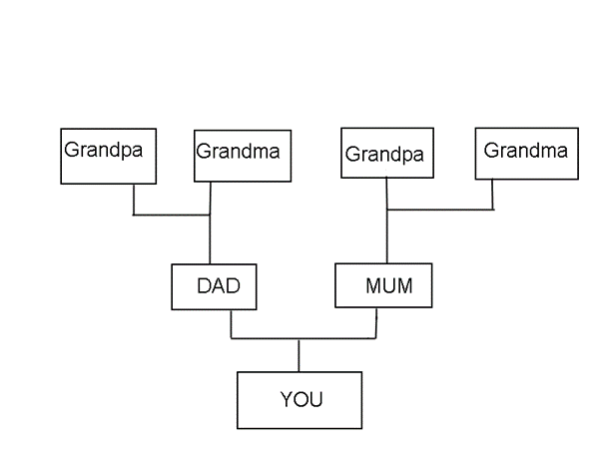A perfect tree is therefore always complete, but a complete tree is not necessarily perfect

* **Infinite complete binary tree**: Here every node has two children (and so the set of levels is countably infinite). The set of all nodes is countably infinite, but the set of all infinite paths from the root is uncountable, having the cardinality of the continuum.

These paths correspond by an order-preserving bijection to the points of the Cantor set, or (using the example of a Stern Brocot tree to the set of positive irrational numbers

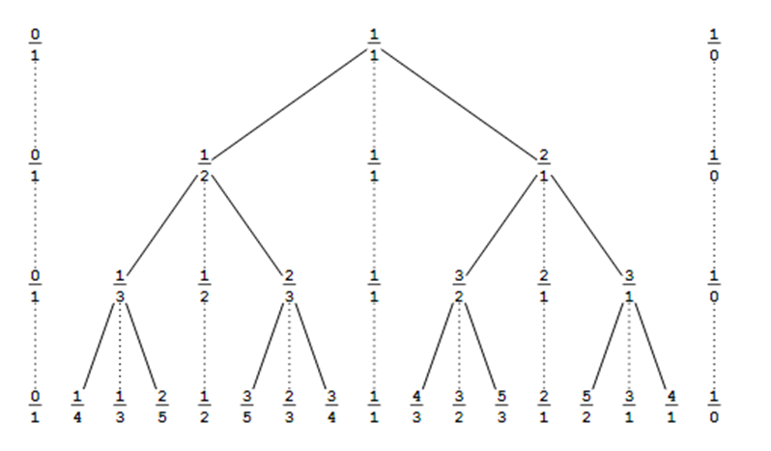

The Stern–Brocot tree, and the Stern–Brocot sequences of order i for i = 1, 2, 3, 4.

* **Balanced binary tree** It is a binary tree structure in which the left and right subtrees of every node differ in height by no more than 1.

Following are the conditions for a height-balanced binary tree:

* difference between the left and the right subtree for any node is not more than one
* the left subtree is balanced
* 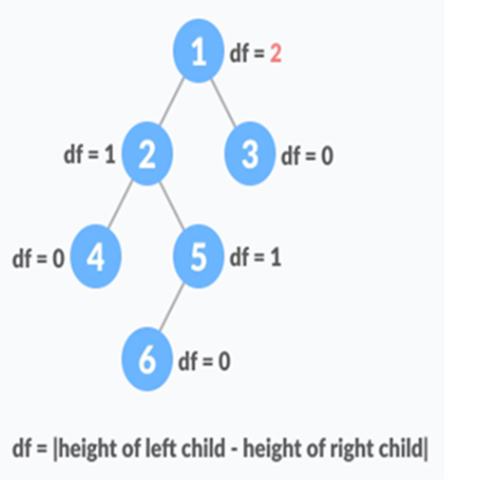the right subtree is balanced

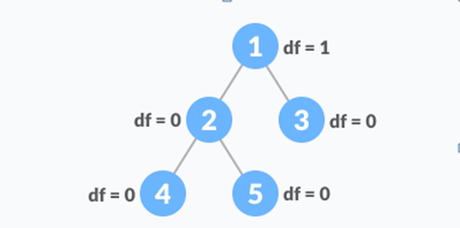

Balanced binary tree with depth at each level Unbalanced binary tree with depth at each node

* **Degenerate (or pathological) tree** it is one where each parent node has only one associated child node. This means that the tree will behave like a linked list data structure

